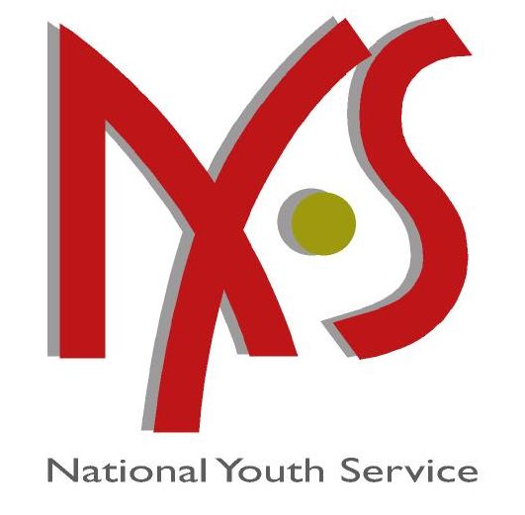
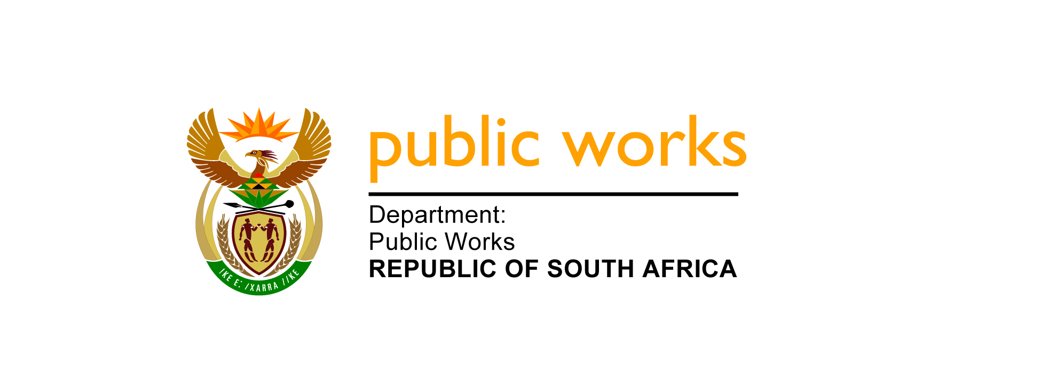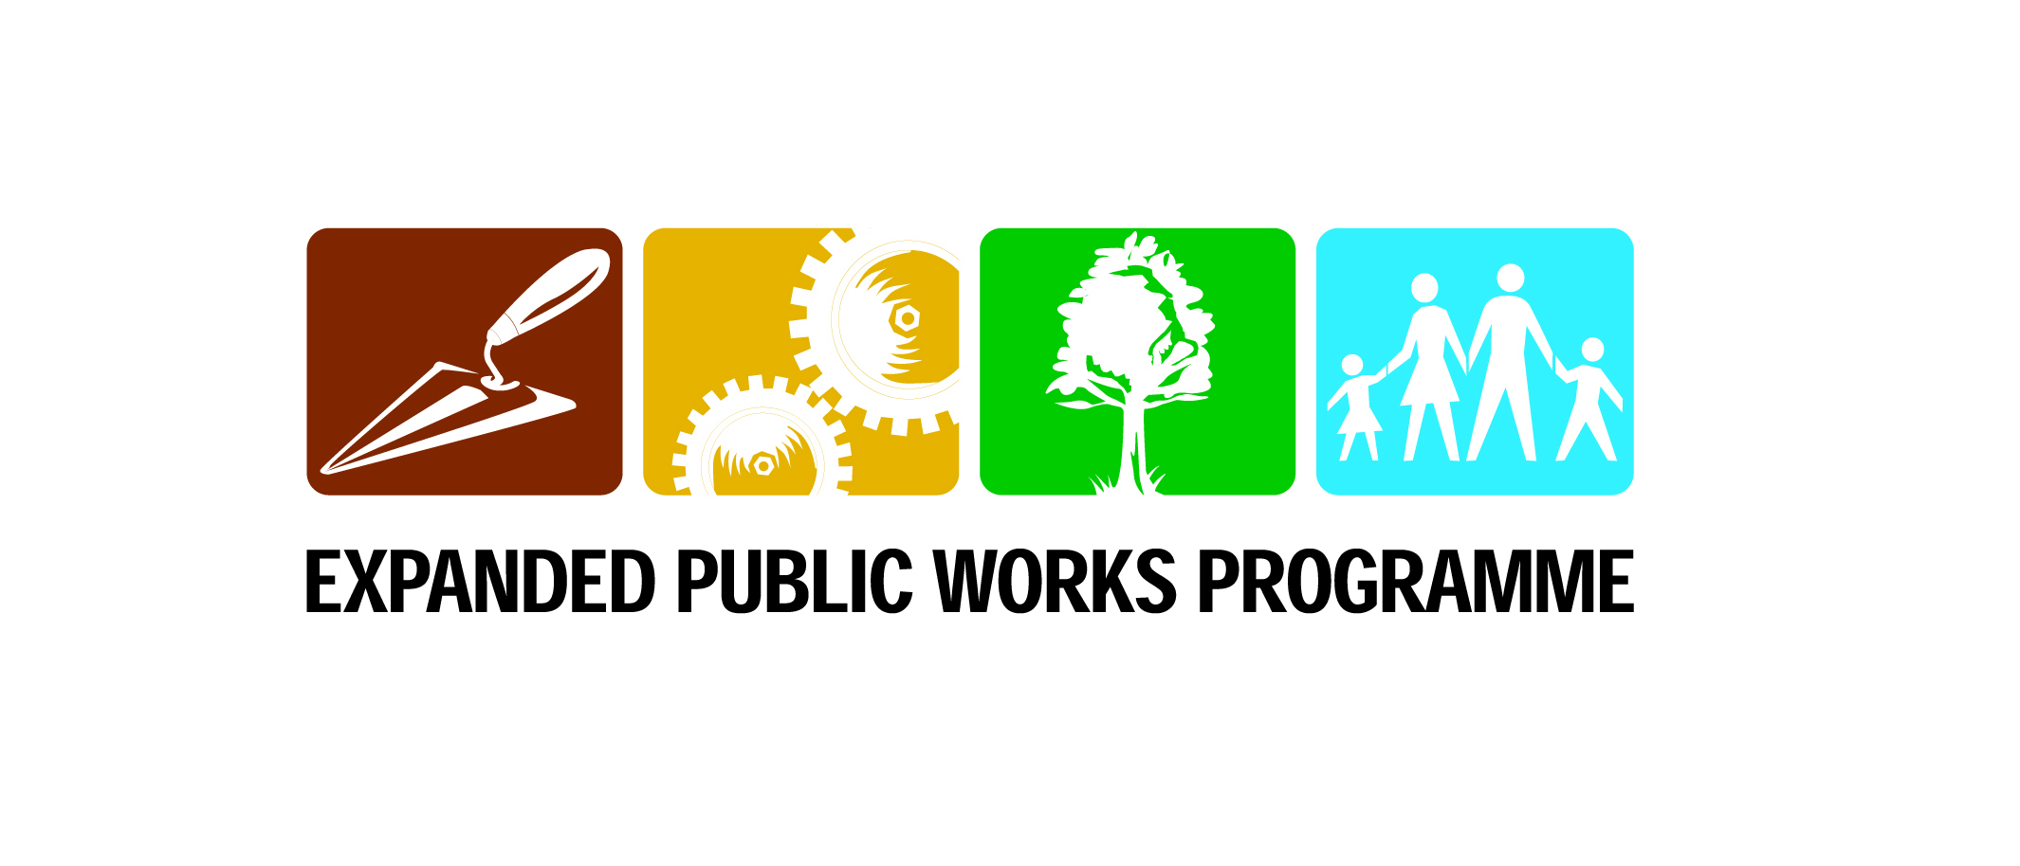

EPWP - NATIONAL YOUTH SERVICE

BRIEFING NOTES

- NYS Objectives

- Ensure participation of youth in the National Youth Service and EPWP through service activities in the Built Environment.
- Ensure that youth develop skills, understanding and aspirations for working in the built environment
- Exit strategies:
- Facilitate exit opportunities for the youth into:
  - Further education
  - Employment with private sector or other departments/ spheres of government, and
  - entrepreneurship or cooperatives

- What Does the NYS Seeks to Address

- Realization of the shortages of Artisans in the Built Environment
- All government departments required to utilize state expenditure for job creation and skills development
- DPW contribution to job creation, set aside Building Construction, Rehabilitation and Maintenance Project for NYS

- Target Groups

- Unemployed youth, aged between 18 - 35, interest in built environment artisan career, resides close to project location, meets entry requirements for training (Grade 12 or 10 with Maths & Science)
- Unemployed Built Environment Graduates and Drop-outs (University, Technikons, FET colleges).

- Youth Recruitment

- Youth fill in Applications Forms attach copy of ID & Certificates
- Short-listing and successful candidates are called for a written assessment
- Candidates who score high scores are selected into the programme and undergo induction
- After the induction candidates take the sign a Contract and a Code of Conduct and go for training

- Training

- Induction (2 Weeks) NYDA
- Life skills (10 Days) DPW/NYDA
- Technical training (6 months) DPW/FET
  - National Certificate: Community House Building Level 2
- Entrepreneurship/ Coops/ Additional Technical Skills (10 days) NYDA
- Introduction to the Built Environment (5 days) DPW

- Activities & Results

- Landscaping
- Painting
- Bricklaying & Plastering
- Tiling
- Carpentry
- Fitting of doors, windows and glass
- Plumbing
- Electrical works

- Practical Work

- Youth will work in order of preference, but taking into account practicalities for a period of 6 months attached to a project:
  - As assistants to artisans in areas they have been trained : bricklaying, painting, tiling etc. (e.g. mixing adhesive for tilers)
  - As manual labourers (Moving bricks, cleaning site)

- Outcomes

- Youth who:

  - Understand value of work, productivity
  - Understand citizenship and workplace values
  - Are independent and self-confident
  - Have good communication skills
  - Have basic competency in respective trades
  - Have income through: DPW employment, other private sector employment, self-employment

- Recommended Allowances

- In training (DoL / DPW):
  - R 660 per month for food and transport
- While working (DPW)
  - R1460 a month

